Hand in 6 – Sorbtion of Copper and Lead
By Eirik Storrud Røsvik

Both solutions uses 0.001 mmol/l of lead/copper. 0.001 sorbed equivalates to 100% sorbed.
1.
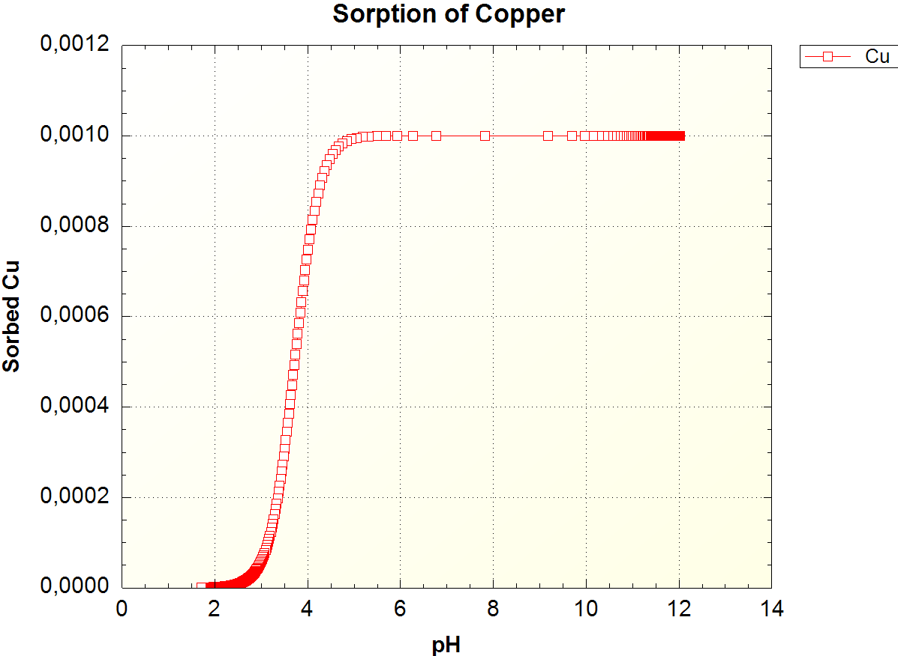
pH | Percentage copper sorbed
12 | 0%
10 | 0%
8 | 0%
6 | 0.01%
4 | 25.21%
The sorbed percentages were read from the xls file produced by the phreeqc script. For pH higher than around 5, the copper is mostly sorbed. When the pH goes bellow 5, the copper is rapidly going into solution, and for pH bellow 3, almost all of the copper is is solution (94.05%). The model gives 99% of the copper is in solution at pH 2.5.

3.
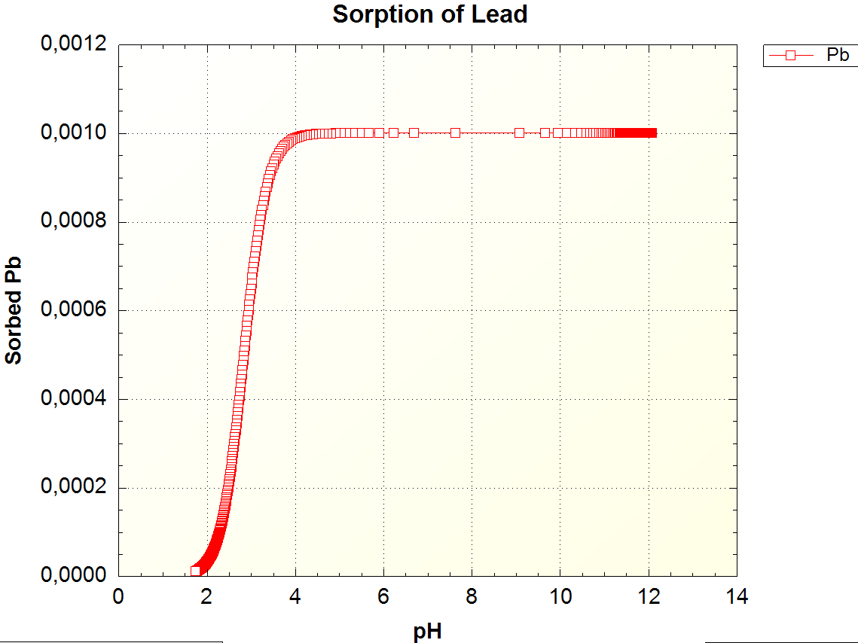
pH | Percentage lead sorbed
12 | 0%
10 | 0%
8 | 0%
6 | 0%
4 | 0.93%
3 | 35.06%

Lead is slower to get reabsorbed into solution, and stays adsorbed to particles at lower pH values than copper. For lead, almost all is sorbed at 4 ph, while for copper a pH of 5 was needed for the same levels. 78% of the lead is in solution at pH 2.5, for copper this pH gave more than 99% of the copper in solution. The difference in behavior is that lead will adsorb to particles at lower pH than copper, or said in other words, copper is more solvable in acidic environments. Following this behavior, copper will also start dissolving at a higher pH than lead. The difference in beaviour can be explained by the difference in ionic charge; Copper can have a charge of +1 or +2, while lead has ionic charges of +2 and +4. In regards to sorbtion to particles, a higher ionic charge results in a stronger bonding to the particle.

